Welcome to 2026

A new year is a time for change. Let us help you make that change with our

FREE Courses & Workshops

for Parents
Several courses are already fully booked so book now to avoid missing out

Please forward this email to share with parents and colleagues.

If you have any problems viewing this email or clicking on the buttons, all of the information and flyers can be found on our website. https://www.supportinglinks.co.uk/whatson.html

These are all funded by Herts County Council so are free for parents to attend.

Courses

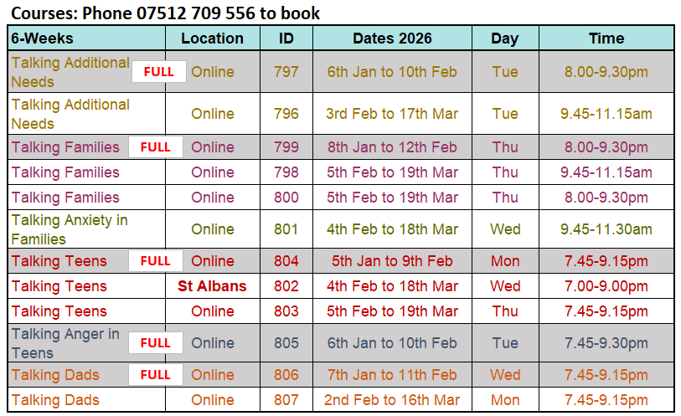

Parents can book by phoning 07512 709556
Or email bookings@supportinglinks.co.uk
Please include your phone number as we cannot book a place without speaking to you.

Professionals can contact us for priority places for parents they are working with.

Our flyers are available in PDF and JPG (picture) formats
Full details are also on our website. https://www.supportinglinks.co.uk/whatson.html

  Course Information (PDF)
  Course Information Pg 1 (JPG)
  Course Information Pg2 (JPG)

  Bitesize Workshops
  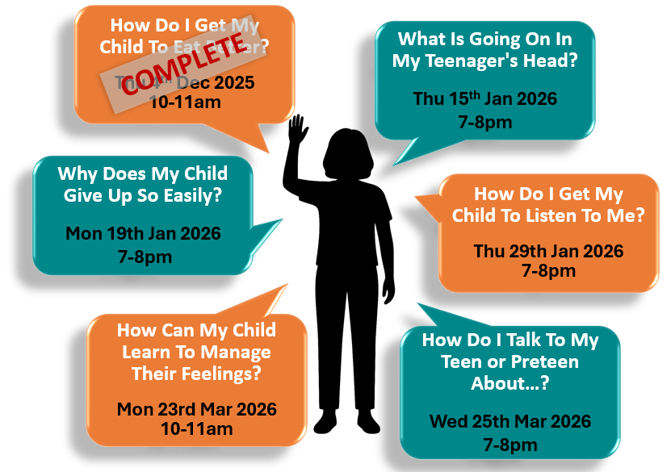
  Our Bitesize Workshops answer your common parenting questions.
  These are interactive 1 hour sessions on Zoom with an opportunity to ask questions.
  Book through Eventbrite
  https://www.eventbrite.co.uk/cc/bitesize-parenting-free-for-parents-in-herts-3853843
  Book a place
  Recording available on request

Talking ASD & ADHD Workshops

Interactive, informative workshops on Zoom with an opportunity to talk questions.
Book through Eventbrite https://www.eventbrite.co.uk/cc/talking-asd-adhd-free-for-parents-in-herts-1046969

Book a place

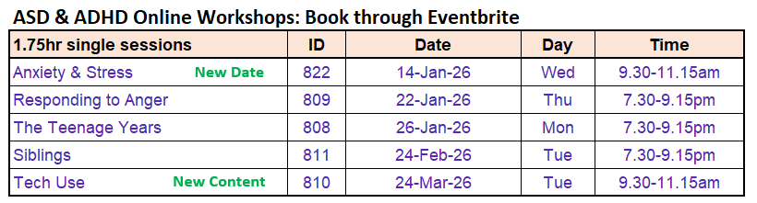

Recording available to all attendees and booked participants on request

  Parent Newsletter
  Our Website

 |  | 

You received this email because you are subscribed to our list. You can unsubscribe at any time.

Supporting Links, EO Physical Return Address, 86-90 Paul Street, London, EC2A 4NE, United Kingdom



