Dear Parents and Carers,
Thanks to those of you that made it to our anxiety coffee afternoon a couple of weeks ago. It is clear that children are continuing to feel anxious and that parents can often feel unsure as to how best to support their children. In this email you'll find plenty of resources that can help support you better to support your children. I have also attached the slides presented at our workshop on anxiety last term, as well as a newsletter from WithYOUth which is jam packed with even more resources! Please take some time to have a look at the resources to ascertain which would be most relevant to your family's experiences. It would also be wonderful if you could let us know if you make use of any of these resources, so we can pass on any feedback to the rest of the William Ransom community.
The local charity Nessie is running an evening of talks on anxiety in Royston on Thursday 26th March - please see the flyer below. Although tickets are £20, please do contact us if you would appreciate us applying for a funded ticket as I believe a few are available.
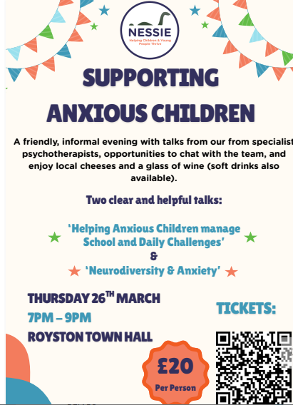
If you haven't had a look at this offer yet, please do take a few minutes to explore The Sandbox - a fantastic Mental Health online resource set up by the NHS that offers a wealth of resources, some courses for young people to work through as well as access to NHS funded online therapy. A good start would be to watch the 2 minute video on the linked page to find out more.
The Charlie Waller Trust is a fantastic charity that aims to provide mental health training and resources with a focus on children and young people. I'd highly recommend looking through their Mental Health Resources section using the search tab to find areas relevant to you. The areas I have found that may be of interest include Supporting a child with depression and Supporting a young person with thoughts of suicide. If you are worried about your child's eating, have a look at Supporting a child with an eating problem. The Trust have also introduced some new Eating disorder workshops.
They also have a helpful section on Supporting a child with anxiety There is also an excellent Webinar on anxiety around change and uncertainty
For those that aren't aware, Neve from the Mental Health Support Team can offer a program of 6 one to one sessions working directly with parents, providing support with anxiety as well as behaviour. The sessions take place on Thursdays and can happen in school or online. If this is something you'd be interested in, please do let me know and we can discuss a referral in more detail.
Lastly, I wanted to let you know that we'll be running another afternoon workshop after Half Term, this time focusing on behaviour. The workshop will take place on Thursday 19th March, 2-3pm so please save the date!
Wishing you a restful half term break.
Best wishes,
Nicole Airey

